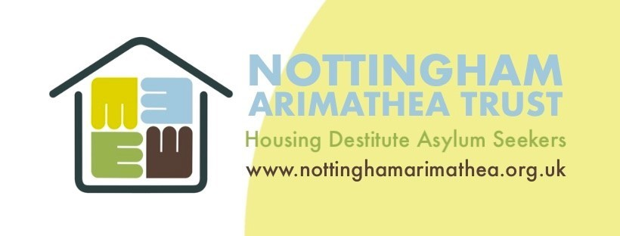

TRUSTEES RECRUITMENT INFORMATION PACK
January 2023

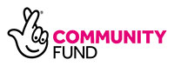
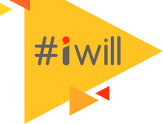
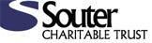
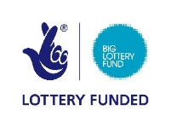

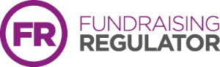

Nottingham Arimathea Trust Vision

No migrant should experience destitution.

Nottingham Arimathea Trust Mission

To ensure that Refugees, Asylum Seekers, Victims of Trafficking and Modern Slavery and other vulnerable migrants, with no access to public funds, in the East Midlands area, be supported out of destitution through the provision of temporary housing and enabled to become independent.

WHAT WE DO

Nottingham Arimathea Trust provides housing and support for people who have had their first claim for asylum refused and for refugees who have become or who are threatened with homelessness. We currently offer accommodation in 20 units – comprising 9 flats, a bungalow (in a sustainable community), 2 family homes and 8 shared houses. We also work to raise awareness of the plight and dispel the myths and stereotyping surrounding asylum seekers and refugees.

Destitute Asylum Seekers
We provide short-term housing and support to enable those with reasonable chances of having their claims accepted for refugee protection, to have the space to live in safety, with some sense of normality, whilst concentrating on their asylum claims. Nearly all our cases are referred to us by Nottingham and Nottinghamshire Refugee Forum (NNRF), and Frameworks Street Outreach Team, British Red Cross, with whom we work closely to provide the support our residents need.

We ensure that everyone we house has adequate legal representation so they can work toward submitting fresh claims for asylum and, from there, access temporary Asylum Support housing (provided by the Home Office whilst these fresh claims are being assessed). We also support people to find medical support, volunteering opportunities and English classes so they can improve their day-to-day lives and develop skills whilst they are working on asylum claims.

Newly-recognised Refugees
For refugees who are entitled to public funds, including housing benefit or housing costs element of Universal Credit, we offer:

− Provision of a ‘first home’ in the form of a one bedroom flat, a room in a shared house or a family home, dependant on availability and household composition.

− Staff support for residents to gain independence ie. Referrals to agencies to assist with home furnishing, job-hunting, receipt of benefits, opening bank accounts etc.

− Opportunities to develop the volunteering skills of residents, through involvement in Nottingham Arimathea Trust and other local agencies.

− Volunteer input to support residents and further refugee referrals for our mentoring work.

− Help to overcome isolation through friendship groups and accessing social networks, linking with Refugee Community Organisations and the many social events organised through The British Red Cross Tuesday Night Project, and the Rainbow Project etc.

Campaigning
As one of the UK’s leading support organisations in this arena, we are at the forefront of campaigns to highlight the plight of asylum seekers and refugees. This work includes:

− Using our expertise to play a leading role in NACCOM - the UK-wide No Accommodation Network.

− Sharing information with supporters about opportunities to get involved in campaigns, through Social Media and also a regular supporters newsletter.

− Facilitating access for residents and supporters to take part in campaigns and demonstrations to get their voices heard locally and nationally. This includes working with other agencies to provide case studies to help with specific campaigns.

Structure & Finance
Nottingham Arimathea Trust was formed in 2007 and is a Company Limited by Guarantee (No:06006531) and registered as a charity (No:1121297). The charity is currently governed by a board of 6 trustees who meet bimonthly.
Nottingham Arimathea Trust is based on the outskirts of Nottingham City, the organisation has 10 employees (9.5 FTE) and 7 regularly active volunteers (excluding trustee roles).
The main source of income is rental income from refugees living in our properties together with grants including the Big Lottery Community Fund and Lloyds Bank Foundation. Additional income is received through community fundraising and donations from organisations and individuals.

BUSINESS Plan
Nottingham Arimathea Trust’s business plan outlines aims over a five-year period; we are currently working to:

- Expand the accommodation and support we offer from 20 units to 30 housing a total of 100 people.

- To develop legal support for residents by delivering 3 of Asylum & Protection regulated activity through the Office of the Immigration Services Commission (OISC).

- To strengthen our strategic position and profile as a leading provider of accommodation and support to refuges and destitute asylum seekers.

Underpinning this work Nottingham Arimathea Trust is also working to improve our infrastructure and long-term financial sustainability. In particular we are working to:

- To strengthen our business and financial model including a five year financial strategy and improvements to budgeting and financial monitoring.

- To develop our organisational infrastructure, including leadership and staff capacity to take account of projected growth.

- To strengthen the governance of Nottingham Arimathea Trust including regular skill audits, training, and the recruitment and induction of new trustees.

Role of the Trustee
A charity is best placed to achieve its ambitions and aims if it has effective governance and the right leadership structures. Good governance enables and supports a charity’s compliance with relevant legislation and regulation. It also promotes attitudes and a culture where everything works towards fulfilling the charity’s vision.
The Charity Governance Code highlights seven principles for good governance:
- Organisational purpose - The board is clear about the charity’s aims and ensures that these are being delivered effectively and sustainably.

- Leadership - Every charity is led by an effective board that provides strategic leadership in line with the charity’s aims and values.

- Integrity - The board acts with integrity, adopting values and creating a culture which help achieve the organisation’s charitable purposes. The board is aware of the importance of the public’s confidence and trust in charities, and trustees undertake their duties accordingly.

- Decision-making, risk and control - The board makes sure that its decision-making processes are informed, rigorous and timely and that effective delegation, control and risk assessment and management systems are set up and monitored.

- Board effectiveness - The board works as an effective team, using the appropriate balance of skills, experience, backgrounds and knowledge to make informed decisions.

- Diversity - The board’s approach to diversity supports its effectiveness, leadership and decision-making.

- Openness and accountability - The board leads the organisation in being transparent and accountable. The charity is open in its work, unless there is good reason for it not to be.

More details on the trustee role can be found in the Role Description and Person Specification document.

Recruitment Process
If you are interested in joining the board please send your expression of interest to Andrew Wilson, Chair of Trustees at: chair@nottinghamarimathea.org.uk Please include:
- Full contact details
- Details of relevant experience/qualifications
- A brief outline of why you are interested in the role and what you feel you can bring to the organisation.
Following shortlisting there will be an opportunity to visit Nottingham Arimathea Trust, including a short interview. Successful candidates will be invited to observe a board meeting and assuming both parties wish to continue, the role will then be formalised.

