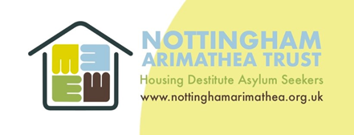

GUIDELINES FOR ACADEMIC RESEARCH AT NOTTINGHAM ARIMATHEA TRUST (NAT)

NAT wishes to encourage the study and dissemination of information around forced migration, and its resultant impact, in academia and to the wider public.
However, we also recognise the need to protect our beneficiaries from unwanted intrusion and questioning about experiences in their lives which may have been traumatic or distressing.
In order to balance these two opposing ends we will only give permission for research to be conducted with our residents and on our premises if we believe it will reach a wide audience or meet a specific need. Where this is the case, NAT will provide a space to advertise research opportunities to our residents and if residents express an interest in taking part, we will assist to facilitate their participation.
If you are interested in conducting research within NAT, please complete the attached form and email it to research@nottinghamarimathea.org.uk
Members of NAT management will consider these requests on a monthly basis, and decide each application on its merit, based on the following criteria:
- Relevance of the topic
- Influence of the research
- Reach of the research
- Disruption to NAT’s work
- Potential distress to our beneficiaries

Research Request Form
Name of the researcher
University
Course of Study
Level
Title of research
Relevant experience
How will your research benefit NAT?

How will your research benefit those researched?

Do you have a pre-existing connection with NAT?
What form will the research take (interviews/surveys/focus groups/staff/service users/films/recording/written)
How long do you envisage this will take?
Do you have ethics agreement from your university/awarding institution
Who will your research reach?

__________________________________________________________________________________
For Office Use Only
Approved for research with residents at NAT | Approved for invitation to a meeting

